**Program No: 01 Date:10-08-2022**

**Aim**: Design a login form with Username and Password using linear layout and toast valid credentials.

**Program Code:**

**activity.xml**

*<?*xml version="1.0" encoding="utf-8"*?>*<LinearLayout  
 xmlns:android="http://schemas.android.com/apk/res/android"  
 xmlns:app="http://schemas.android.com/apk/res-auto"  
 xmlns:tools="http://schemas.android.com/tools"  
 android:layout_width="match_parent"  
 android:layout_height="match_parent"  
 tools:context=".MainActivity"  
 android:orientation="vertical">  
  
 <TextView  
 android:layout_width="wrap_content"  
 android:layout_height="wrap_content"  
 android:text="Login"  
 android:textSize="@dimen/cardview_default_radius"/>  
  
 <EditText  
 android:layout_width="match_parent"  
 android:layout_height="wrap_content"  
 android:hint="username"  
 android:id="@+id/et1"  
 />  
 <EditText  
 android:layout_width="match_parent"  
 android:layout_height="wrap_content"  
 android:hint="password"  
 android:id="@+id/et2"  
 android:layout_marginTop="10dp"  
 android:inputType="textPassword"  
 />  
 <Button  
 android:layout_width="wrap_content"  
 android:layout_height="wrap_content"  
 android:text="Login"  
 android:id="@+id/btn"  
 android:layout_marginLeft="140dp"  
 />

</LinearLayout>

**Mainactivity.java**

package com.example.login;  
import androidx.appcompat.app.AppCompatActivity;  
  
import android.os.Bundle;  
import android.view.View;  
import android.widget.Button;  
import android.widget.EditText;  
import android.widget.Toast;  
  
public class MainActivity extends AppCompatActivity {  
  
 @Override  
 protected void onCreate(Bundle savedInstanceState) {  
 super.onCreate(savedInstanceState);  
 setContentView(R.layout.*activity_main*);  
 EditText et1=findViewById(R.id.*et1*);  
 EditText et2=findViewById(R.id.*et2*);  
 Button button=findViewById(R.id.*btn*);  
button.setOnClickListener(new View.OnClickListener() { @Override  
 public void onClick(View view) {  
 validate(et1.getText().toString(),et2.getText().toString());  
 }  
 private void validate(String us,String pw)  
 {  
 if(us.equals("admin")&&pw.equals("1234"))  
 {  
 Toast.*makeText*(getApplicationContext(),"Login successfull",Toast.*LENGTH_LONG*).show();  
 }  
 else  
 {  
 Toast.*makeText*(getApplicationContext(),"Unsuccessfull login",Toast.*LENGTH_LONG*).show();  
 }  
 }  
 });  
 }  
}

**Result:** Program compiled successfully and output verified.

**Output**

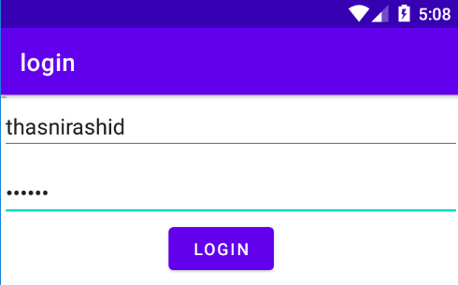

**Program No: 02 Date:16-08-2022**

**Aim**: Write a program to demonstrate the activity life cycle.

**Program Code:**

**activity.xml**

*<?*xml version="1.0" encoding="utf-8"*?>*<androidx.constraintlayout.widget.ConstraintLayout xmlns:android="http://schemas.android.com/apk/res/android"  
 xmlns:app="http://schemas.android.com/apk/res-auto"  
 xmlns:tools="http://schemas.android.com/tools"  
 android:layout_width="match_parent"  
 android:layout_height="match_parent"  
 tools:context=".MainActivity">  
  
 <TextView  
 android:layout_width="wrap_content"  
 android:layout_height="wrap_content"  
 android:text="Hello World!"  
 app:layout_constraintBottom_toBottomOf="parent"  
 app:layout_constraintLeft_toLeftOf="parent"  
 app:layout_constraintRight_toRightOf="parent"  
 app:layout_constraintTop_toTopOf="parent" />

**Mainactivity.java**

package com.example.myapplication;  
  
import androidx.appcompat.app.AppCompatActivity;  
  
import android.os.Bundle;  
import android.util.Log;  
  
public class MainActivity extends AppCompatActivity {  
  
 @Override  
 protected void onCreate(Bundle savedInstanceState) {  
 super.onCreate(savedInstanceState);  
 setContentView(R.layout.*activity_main*);  
 Log.*d*("lifecycle","onCreate invoked");  
 }  
 @Override  
 protected void onStart() {  
 super.onStart();  
 Log.*d*("lifecycle","onStart invoked");  
 }  
 @Override  
 protected void onResume() {  
 super.onResume();  
 Log.*d*("lifecycle","onResume invoked");  
 }  
 @Override  
 protected void onPause() {  
 super.onPause();  
 Log.*d*("lifecycle","onPause invoked");  
 }  
 @Override  
 protected void onStop() {  
 super.onStop();  
 Log.*d*("lifecycle","onStop invoked");  
 }  
 @Override  
 protected void onRestart() {  
 super.onRestart();  
 Log.*d*("lifecycle","onRestart invoked");  
 }  
 @Override  
 protected void onDestroy() {  
 super.onDestroy();  
 Log.*d*("lifecycle","onDestroy invoked");  
 }  
}

**Result:** Program compiled successfully and output verified.

**Output**

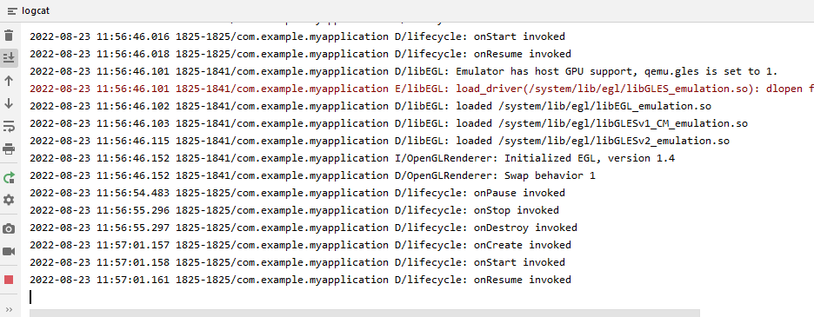

**Program No: 03 Date:19-08-2022**

**Aim**:Implementing basic arithmetic operations of a simple calculator.

**Program Code:**

**activity.xml**

*<?*xml version="1.0" encoding="utf-8"*?>*<LinearLayout  
 xmlns:android="http://schemas.android.com/apk/res/android"  
 xmlns:app="http://schemas.android.com/apk/res-auto"  
 xmlns:tools="http://schemas.android.com/tools"  
 android:layout_width="match_parent"  
 android:layout_height="match_parent"  
 tools:context=".MainActivity"  
 android:orientation="vertical">  
  
 <TextView  
 android:layout_width="wrap_content"  
 android:layout_height="wrap_content"  
 android:text="Simple calculator"/>  
 <TextView  
 android:layout_width="match_parent"  
 android:layout_height="wrap_content"  
 android:text="Enter 1st number"/>  
 <EditText  
 android:layout_width="wrap_content"  
 android:layout_height="wrap_content"  
 android:hint="Enter 1st number"  
 android:id="@+id/n1"/>  
 <TextView  
 android:layout_width="match_parent"  
 android:layout_height="wrap_content"  
 android:text="Enter the 2nd number"/>  
 <EditText  
 android:layout_width="wrap_content"  
 android:layout_height="wrap_content"  
 android:hint="Enter the 2nd number"  
 android:id="@+id/n2"/>  
 <TextView  
 android:layout_width="wrap_content"  
 android:layout_height="wrap_content"  
 android:id="@+id/t1"/>  
 <LinearLayout  
 android:layout_width="wrap_content"  
 android:layout_height="wrap_content">  
 <Button  
 android:layout_width="wrap_content"  
 android:layout_height="wrap_content"  
 android:text="Add"  
 android:id="@+id/b1"/>  
 <Button  
 android:layout_width="wrap_content"  
 android:layout_height="wrap_content"  
 android:text="Sub"  
 android:id="@+id/b2"/>  
 <Button  
 android:layout_width="wrap_content"  
 android:layout_height="wrap_content"  
 android:text="Mul"  
 android:id="@+id/b3"/>  
 <Button  
 android:layout_width="wrap_content"  
 android:layout_height="wrap_content"  
 android:text="Div"  
 android:id="@+id/b4"/>  
 </LinearLayout>  
  
</LinearLayout>

**Mainactivity.java**

package com.example.calculator;  
  
import androidx.appcompat.app.AppCompatActivity;  
  
import android.os.Bundle;  
import android.view.View;  
import android.widget.Button;  
import android.widget.EditText;  
import android.widget.TextView;  
  
public class MainActivity extends AppCompatActivity {  
  
 @Override  
 protected void onCreate(Bundle savedInstanceState) {  
 super.onCreate(savedInstanceState);  
 setContentView(R.layout.*activity_main*);  
 EditText t1=findViewById(R.id.*n1*);  
 EditText t2=findViewById(R.id.*n2*);  
 Button add=findViewById(R.id.*b1*);  
 Button sub=findViewById(R.id.*b2*);  
 Button mul=findViewById(R.id.*b3*);  
 Button div=findViewById(R.id.*b4*);  
 TextView tv1=findViewById(R.id.*t1*);  
 add.setOnClickListener(new View.OnClickListener() {  
 @Override  
 public void onClick(View view) {  
 Double a1 = Double.*parseDouble*(t1.getText().toString());  
 Double a2 = Double.*parseDouble*(t2.getText().toString());  
 Double r = a1 + a2;  
 tv1.setText("Result is: " + String.*valueOf*(r));  
 }  
 });  
 sub.setOnClickListener(new View.OnClickListener() {  
 @Override  
 public void onClick(View view) {  
 Double s1=Double.*parseDouble*(t1.getText().toString());  
 Double s2=Double.*parseDouble*(t2.getText().toString());  
 Double r=s1-s2;  
 tv1.setText("Result is: "+String.*valueOf*(r));  
 }  
 });  
 mul.setOnClickListener(new View.OnClickListener() {  
 @Override  
 public void onClick(View view) {  
 Double m1 = Double.*parseDouble*(t1.getText().toString());  
 Double m2 = Double.*parseDouble*(t2.getText().toString());  
 Double r = m1 * m2;  
 tv1.setText("Result is" + String.*valueOf*(r));  
  
 }  
 });  
 div.setOnClickListener(new View.OnClickListener() {  
 @Override  
 public void onClick(View view) {  
 Double d1=Double.*parseDouble*(t1.getText().toString());  
 Double d2=Double.*parseDouble*(t2.getText().toString());  
 Double r=d1/d2;  
 tv1.setText("Result is" +String.*valueOf*(r));  
 }  
 });  
  
  
 }  
  
}

**Result:** Program compiled successfully and output verified.

**Output**

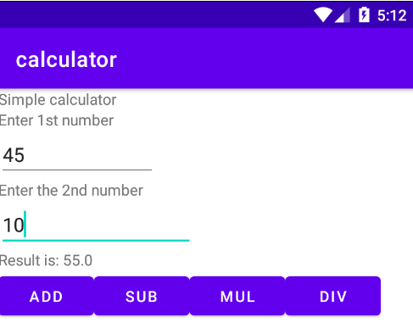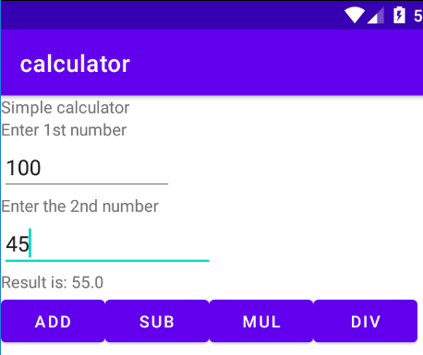

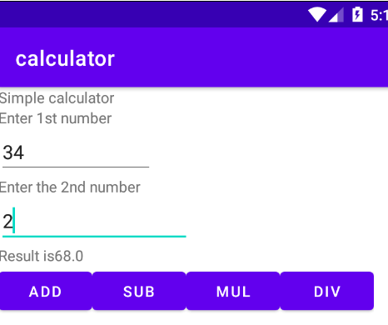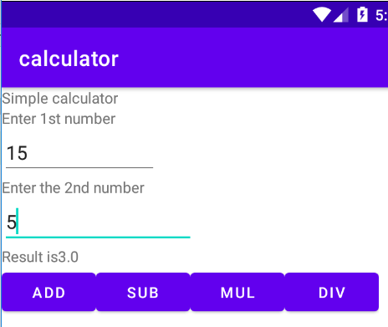

**Program No: 04 Date:23-08-2022**

**Aim**:Implement validation on various UI controls.

**Program Code:**

**activity.xml**

*<?*xml version="1.0" encoding="utf-8"*?>*<LinearLayout xmlns:android="http://schemas.android.com/apk/res/android"  
 xmlns:app="http://schemas.android.com/apk/res-auto"  
 xmlns:tools="http://schemas.android.com/tools"  
 android:layout_width="match_parent"  
 android:layout_height="match_parent"  
 android:orientation="vertical"  
 tools:context=".MainActivity">  
  
 <TextView  
 android:layout_width="match_parent"  
 android:layout_height="wrap_content"  
 android:text="REGISTRATION"  
 android:textColor="@color/design_default_color_error"  
 android:textSize="30dp"/>  
 <EditText  
 android:layout_width="match_parent"  
 android:layout_height="wrap_content"  
 android:hint="NAME"  
 android:id="@+id/name"/>  
 <EditText  
 android:layout_width="match_parent"  
 android:layout_height="wrap_content"  
 android:hint="MOBILE NUMBER"  
 android:id="@+id/mobile"/>  
 <EditText  
 android:layout_width="match_parent"  
 android:layout_height="wrap_content"  
 android:hint="AGE"  
 android:id="@+id/age"/>  
 <TextView  
 android:layout_width="wrap_content"  
 android:layout_height="wrap_content"  
 android:text="GENDER"  
 android:textSize="20dp"  
 android:textColor="@color/design_default_color_primary"/>  
 <RadioGroup  
 android:layout_width="wrap_content"  
 android:layout_height="wrap_content"  
 android:id="@+id/RG">  
 <RadioButton  
 android:layout_width="wrap_content"  
 android:layout_height="wrap_content"  
 android:id="@+id/radiobutton1"  
 android:text="Male"/>  
 <RadioButton  
 android:layout_width="wrap_content"  
 android:layout_height="wrap_content"  
 android:id="@+id/radiobutton2"  
 android:text="Female"/>  
 </RadioGroup>  
 <Button  
 android:layout_width="wrap_content"  
 android:layout_height="wrap_content"  
 android:text="Submit"  
 android:id="@+id/button"/>  
 <CheckBox  
 android:layout_width="wrap_content"  
 android:layout_height="wrap_content"  
 android:text="i agree all terms and conditions"  
 android:id="@+id/checkbox"/>

</LinearLayout

**Mainactivity.java**

package com.example.validation;  
  
import androidx.appcompat.app.AppCompatActivity;  
  
import android.content.Intent;  
import android.os.Bundle;  
import android.view.View;  
import android.widget.Button;  
import android.widget.CheckBox;  
import android.widget.EditText;  
import android.widget.RadioButton;  
import android.widget.RadioGroup;  
import android.widget.Toast;  
  
public class MainActivity extends AppCompatActivity {  
 EditText name;  
 EditText mobileno;  
 EditText age;  
 RadioGroup radiogroup;  
 RadioButton male;  
 RadioButton female;  
 CheckBox checkbox;  
 Button button;  
  
 @Override  
 protected void onCreate(Bundle savedInstanceState) {  
 super.onCreate(savedInstanceState);  
 setContentView(R.layout.*activity_main*);  
 name=findViewById(R.id.*name*);  
 mobileno=findViewById(R.id.*mobile*);  
 age=findViewById(R.id.*age*);  
 radiogroup=findViewById(R.id.*RG*);  
 male=findViewById(R.id.*radiobutton1*);  
 female=findViewById(R.id.*radiobutton2*);  
 checkbox=findViewById(R.id.*checkbox*);  
 button=findViewById(R.id.*button*);  
 button.setOnClickListener(new View.OnClickListener() {  
 @Override  
 public void onClick(View view) {  
 if (error()){  
 Intent i=new Intent(MainActivity.this,login.class);  
 startActivity(i);  
 }  
 }  
 });  
 }  
 private boolean error(){  
 if (name.getText().toString().length()==0){  
 Toast.*makeText*(getApplicationContext(),"Please enter the name",Toast.*LENGTH_LONG*).show();  
 return false;  
 }else if (mobileno.getText().toString().length()==0){  
 Toast.*makeText*(getApplicationContext(),"please enter mobile number",Toast.*LENGTH_LONG*).show();  
 return false;  
 }  
 else if (mobileno.getText().toString().length()!=10){  
 Toast.*makeText*(getApplicationContext(),"please enter 10 numbers",Toast.*LENGTH_LONG*).show();  
 return false;  
 }  
 else if (!male.isChecked() && !female.isChecked()){  
 Toast.*makeText*(getApplicationContext(),"please choose radio button",Toast.*LENGTH_LONG*).show();  
 return false;  
 }else if (!checkbox.isChecked()){  
 Toast.*makeText*(getApplicationContext(),"Please click on checkbox",Toast.*LENGTH_LONG*).show();  
 return false;  
 }else {  
 return true;  
 }  
 }

}

**activity_login.xml**

*<?*xml version="1.0" encoding="utf-8"*?>*<LinearLayout xmlns:android="http://schemas.android.com/apk/res/android"  
 xmlns:app="http://schemas.android.com/apk/res-auto"  
 xmlns:tools="http://schemas.android.com/tools"  
 android:layout_width="match_parent"  
 android:layout_height="match_parent"  
 tools:context=".login">  
  
 <TextView  
 android:id="@+id/textView"  
 android:layout_width="wrap_content"  
 android:layout_height="wrap_content"  
 android:text="Welcome to my login page"  
 tools:layout_editor_absoluteX="121dp"  
 tools:layout_editor_absoluteY="194dp" />  
</LinearLayout>

**Login.java**

package com.example.validation;  
  
import androidx.appcompat.app.AppCompatActivity;  
  
import android.os.Bundle;  
  
public class login extends AppCompatActivity {  
  
 @Override  
 protected void onCreate(Bundle savedInstanceState) {  
 super.onCreate(savedInstanceState);  
 setContentView(R.layout.*activity_login*);  
 }

}

**Result:** Program compiled successfully and output verified.

**Output**

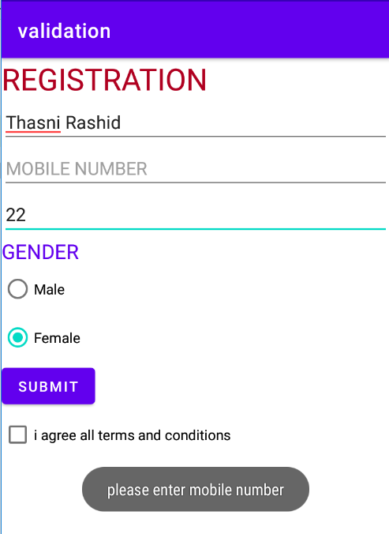

**Program No: 05 Date:26-08-2022**

**Aim**: Design a registration activity and store registration details in local memory of phone using intent and shared preferences.

**Program Code:**

**activity.xml**

*<?*xml version="1.0" encoding="utf-8"*?>*<RelativeLayout xmlns:android="http://schemas.android.com/apk/res/android"  
 xmlns:app="http://schemas.android.com/apk/res-auto"  
 xmlns:tools="http://schemas.android.com/tools"  
 android:layout_width="match_parent"  
 android:layout_height="match_parent"  
 tools:context=".MainActivity"  
 tools:ignore="HardcodedText">  
  
 <TextView  
 android:id="@+id/textview"  
 android:layout_width="wrap_content"  
 android:layout_height="wrap_content"  
 android:layout_centerHorizontal="true"  
 android:layout_marginTop="32dp"  
 android:text="Registration form"  
 android:textColor="@android:color/black"  
 android:textSize="24sp"/>  
 <EditText  
 android:id="@+id/edit1"  
 android:layout_width="match_parent"  
 android:layout_height="wrap_content"  
 android:layout_below="@+id/textview"  
 android:layout_marginStart="16dp"  
 android:layout_marginTop="8dp"  
 android:layout_marginEnd="16dp"  
 android:hint="Enter your name"  
 android:padding="10dp"/>  
 <EditText  
 android:id="@+id/edit2"  
 android:layout_width="match_parent"  
 android:layout_height="wrap_content"  
 android:layout_below="@+id/edit1"  
 android:layout_marginStart="16dp"  
 android:layout_marginTop="8dp"  
 android:layout_marginEnd="16dp"  
 android:hint="Enter your age"  
 android:padding="10dp"  
 android:inputType="number"/>  
 <EditText  
 android:id="@+id/edit3"  
 android:layout_width="match_parent"  
 android:layout_height="wrap_content"  
 android:layout_below="@+id/edit2"  
 android:layout_marginStart="16dp"  
 android:layout_marginTop="8dp"  
 android:layout_marginEnd="16dp"  
 android:hint="Enter your Email id"  
 android:padding="10dp"/>  
 <EditText  
 android:id="@+id/edit4"  
 android:layout_width="match_parent"  
 android:layout_height="wrap_content"  
 android:layout_below="@+id/edit3"  
 android:layout_marginStart="16dp"  
 android:layout_marginTop="8dp"  
 android:layout_marginEnd="16dp"  
 android:hint="Enter your Address"  
 android:padding="10dp"/>  
 <EditText  
 android:id="@+id/edit5"  
 android:layout_width="match_parent"  
 android:layout_height="wrap_content"  
 android:layout_below="@+id/edit4"  
 android:layout_marginStart="16dp"  
 android:layout_marginTop="8dp"  
 android:layout_marginEnd="16dp"  
 android:hint="Enter your gender"  
 android:padding="10dp"/>  
 <EditText  
 android:id="@+id/edit6"  
 android:layout_width="match_parent"  
 android:layout_height="wrap_content"  
 android:layout_below="@+id/edit5"  
 android:layout_marginStart="16dp"  
 android:layout_marginTop="8dp"  
 android:layout_marginEnd="16dp"  
 android:hint="Enter your Qualification"  
 android:padding="10dp"/>  
 <Button  
 android:layout_width="wrap_content"  
 android:layout_height="wrap_content"  
 android:id="@+id/b1"  
 android:layout_below="@+id/edit6"  
 android:text="Submit"/>  
</RelativeLayout>

**MainActivity.java**

package com.example.sharedpreference;  
  
import androidx.appcompat.app.AppCompatActivity;  
  
import android.content.Intent;  
import android.content.SharedPreferences;  
import android.os.Bundle;  
import android.view.View;  
import android.widget.Button;  
import android.widget.EditText;  
  
public class MainActivity extends AppCompatActivity {  
 private EditText name,age,email,address,gender,quali;  
 Button b1;  
  
 @Override  
 protected void onCreate(Bundle savedInstanceState) {  
 super.onCreate(savedInstanceState);  
 setContentView(R.layout.*activity_main*);  
 name=findViewById(R.id.*edit1*);  
 age=findViewById(R.id.*edit2*);  
 email=findViewById(R.id.*edit3*);  
 address=findViewById(R.id.*edit4*);  
 gender=findViewById(R.id.*edit5*);  
 quali=findViewById(R.id.*edit6*);  
 b1=findViewById(R.id.*b1*);  
 b1.setOnClickListener(new View.OnClickListener() {  
 @Override  
 public void onClick(View view) {  
 Intent i=new Intent(MainActivity.this,MainActivity2.class);  
 startActivity(i);  
 }  
 });  
 }  
 protected void onResume() {  
 super.onResume();  
 SharedPreferences sh = getSharedPreferences("mysharedpref", *MODE_PRIVATE*);  
 String s1 = sh.getString("name", "");  
 int a = sh.getInt("age", 0);  
 String s2 = sh.getString("email", "");  
 String s3 = sh.getString("address", "");  
 String s4 = sh.getString("gender", "");  
 String s5 = sh.getString("quali", "");  
 name.setText(s1);  
 age.setText(String.*valueOf*(a));  
 email.setText(s2);  
 address.setText(s3);  
 gender.setText(s4);  
 quali.setText(s5);  
 }  
 protected void onPause() {  
 super.onPause();  
 SharedPreferences sharedPreferences = getSharedPreferences("mysharedpref", *MODE_PRIVATE*);  
 SharedPreferences.Editor myEdit = sharedPreferences.edit();  
 myEdit.putString("name", name.getText().toString());  
 myEdit.putInt("age", Integer.*parseInt*(age.getText().toString()));  
 myEdit.putString("email", email.getText().toString());  
 myEdit.putString("address", address.getText().toString());  
 myEdit.putString("gender", gender.getText().toString());  
 myEdit.putString("quali", quali.getText().toString());  
 myEdit.commit();  
 }  
  
}

**activity_main2.xml**

*<?*xml version="1.0" encoding="utf-8"*?>*<RelativeLayout xmlns:android="http://schemas.android.com/apk/res/android"  
 xmlns:app="http://schemas.android.com/apk/res-auto"  
 xmlns:tools="http://schemas.android.com/tools"  
 android:layout_width="match_parent"  
 android:layout_height="match_parent"  
 tools:context=".MainActivity2">  
 <TextView  
 android:layout_width="wrap_content"  
 android:layout_height="wrap_content"  
 android:text="Welocome"/>  
</RelativeLayout>

**MainActivity2.java**

package com.example.sharedpreference;  
  
import androidx.appcompat.app.AppCompatActivity;  
  
import android.os.Bundle;  
  
public class MainActivity2 extends AppCompatActivity {  
  
 @Override  
 protected void onCreate(Bundle savedInstanceState) {  
 super.onCreate(savedInstanceState);  
 setContentView(R.layout.*activity_main2*);  
 }

}

**Result:** Program compiled successfully and output verified.

**Output**

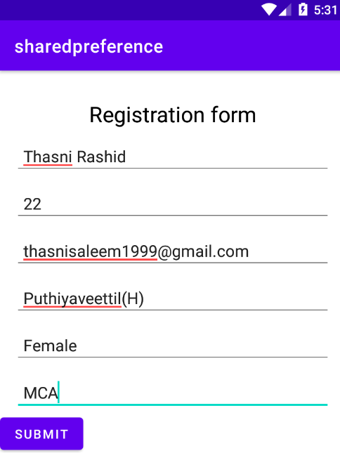

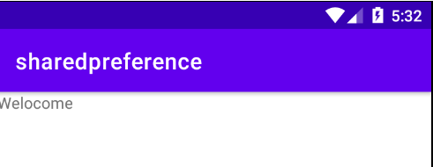

**Program No: 06 Date:30-08-2022**

**Aim**:Design a simple calculator using GridLayout.

**Program Code:**

**Activity_main.xml**

*<?*xml version="1.0" encoding="utf-8"*?>*<GridLayout xmlns:android="http://schemas.android.com/apk/res/android"  
 xmlns:app="http://schemas.android.com/apk/res-auto"  
 xmlns:tools="http://schemas.android.com/tools"  
 android:layout_width="match_parent"  
 android:layout_height="match_parent"  
 tools:context=".MainActivity">  
  
 <TextView  
 android:layout_width="wrap_content"  
 android:layout_height="wrap_content"  
 android:text="Enter 1st num"  
 android:layout_row="0"  
 android:layout_column="0"/>  
 <EditText  
 android:layout_width="wrap_content"  
 android:layout_height="wrap_content"  
 android:id="@+id/n1"  
 android:layout_row="1"  
 android:layout_column="0"/>  
 <TextView  
 android:layout_width="wrap_content"  
 android:layout_height="wrap_content"  
 android:text="Enter 1st num"  
 android:layout_row="2"  
 android:layout_column="0"/>  
 <EditText  
 android:layout_width="wrap_content"  
 android:layout_height="wrap_content"  
 android:id="@+id/n2"  
 android:layout_row="3"  
 android:layout_column="0"/>  
 <Button  
 android:text="ADD"  
 android:layout_width="wrap_content"  
 android:layout_height="wrap_content"  
 android:layout_row="4"  
 android:layout_column="2"  
 android:textColor="@color/white"  
 android:background="@color/design_default_color_error"  
 android:id="@+id/add"/>  
 <Button  
 android:text="MUL"  
 android:layout_width="wrap_content"  
 android:layout_height="wrap_content"  
 android:layout_row="4"  
 android:layout_column="1"  
 android:textColor="@color/white"  
 android:background="@color/design_default_color_error"  
 android:id="@+id/mul"/>  
 <Button  
 android:text="SUB"  
 android:layout_width="wrap_content"  
 android:layout_height="wrap_content"  
 android:layout_row="4"  
 android:layout_column="0"  
 android:textColor="@color/white"  
 android:background="@color/design_default_color_error"  
 android:id="@+id/sub"/>  
 <Button  
 android:text="DIV"  
 android:layout_width="wrap_content"  
 android:layout_height="wrap_content"  
 android:layout_row="4"  
 android:layout_column="3"  
 android:textColor="@color/white"  
 android:background="@color/design_default_color_error"  
 android:id="@+id/div"/>  
  
 <TextView  
 android:hint="Result"  
 android:width="70dp"  
 android:height="50dp"  
 android:layout_row="2"  
 android:layout_column="2"  
 android:id="@+id/result"  
 android:textColor="@color/design_default_color_error"/>  
</GridLayout>

**MainActivity.java**

package com.example.calculator;  
  
import androidx.appcompat.app.AppCompatActivity;  
  
import android.os.Bundle;  
import android.view.View;  
import android.widget.Button;  
import android.widget.EditText;  
import android.widget.TextView;  
  
public class MainActivity extends AppCompatActivity {  
  
 @Override  
 protected void onCreate(Bundle savedInstanceState) {  
 super.onCreate(savedInstanceState);  
 setContentView(R.layout.*activity_main*);  
  
  
 EditText a = findViewById(R.id.*n1*);  
 EditText b = findViewById(R.id.*n2*);  
  
  
 Button add = findViewById(R.id.*add*);  
 Button mul = findViewById(R.id.*mul*);  
 Button sub = findViewById(R.id.*sub*);  
 Button div = findViewById(R.id.*div*);  
 TextView result = findViewById(R.id.*result*);  
 add.setOnClickListener(new View.OnClickListener() {  
 @Override  
 public void onClick(View view) {  
 Double n1 = Double.*parseDouble*(a.getText().toString());  
 Double n2 = Double.*parseDouble*(b.getText().toString());  
 Double r = n1 + n2;  
 result.setText(String.*valueOf*(r));  
 }  
 });  
 sub.setOnClickListener(new View.OnClickListener() {  
 @Override  
 public void onClick(View view) {  
 Double n1 = Double.*parseDouble*(a.getText().toString());  
 Double n2 = Double.*parseDouble*(b.getText().toString());  
 Double r = n1 - n2;  
 result.setText(String.*valueOf*(r));  
 }  
 });  
 mul.setOnClickListener(new View.OnClickListener() {  
 @Override  
 public void onClick(View view) {  
 Double n1 = Double.*parseDouble*(a.getText().toString());  
 Double n2 = Double.*parseDouble*(b.getText().toString());  
 Double r = n1 * n2;  
 result.setText(String.*valueOf*(r));  
 }  
 });  
 div.setOnClickListener(new View.OnClickListener() {  
 @Override  
 public void onClick(View view) {  
 Double n1 = Double.*parseDouble*(a.getText().toString());  
 Double n2 = Double.*parseDouble*(b.getText().toString());  
 Double r = n1 / n2;  
 result.setText(String.*valueOf*(r));  
 }  
 });  
 }

}

**Result:** Program compiled successfully and output verified.

**Output**

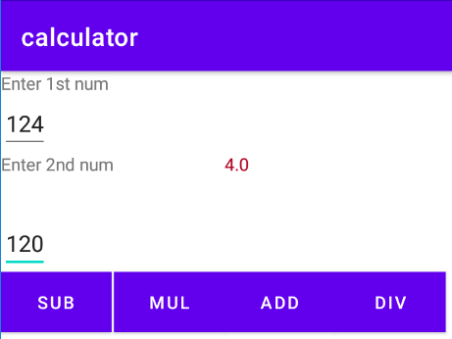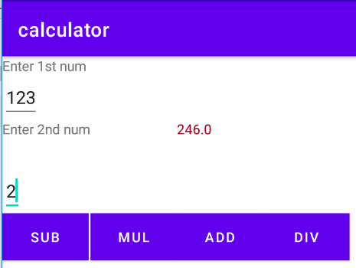

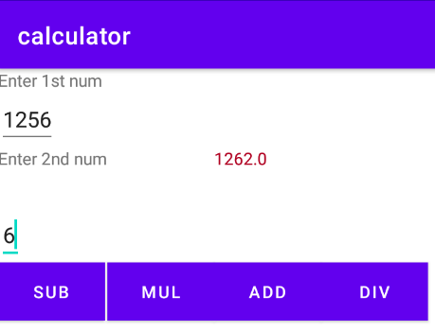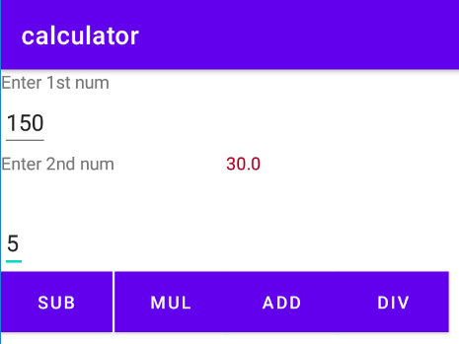

**Program No:07 Date:02-09-2022**

**Aim**:Create a facebook page using RelativeLayout ; set properties using .xml file

**Program Code:**

**Activity_main.xml**

*<?*xml version="1.0" encoding="utf-8"*?>*<RelativeLayout  
 xmlns:android="http://schemas.android.com/apk/res/android"  
 xmlns:tools="http://schemas.android.com/tools"  
 android:id="@+id/activity_main"  
 android:layout_width="match_parent"  
 android:layout_height="match_parent"  
 tools:context=".MainActivity">  
 <RelativeLayout  
 android:id="@+id/relativelayout"  
 android:layout_width="match_parent"  
 android:layout_height="wrap_content">  
 <ImageView  
 android:layout_width="match_parent"  
 android:layout_height="250dp"  
 android:id="@+id/banner"  
 android:src="@drawable/image1"  
 android:scaleType="centerCrop"/>  
 <ImageView  
 android:layout_marginLeft="15dp"  
 android:layout_width="100dp"  
 android:layout_height="150dp"  
 android:id="@+id/profilepic"  
 android:src="@drawable/images2"  
 android:layout_alignBottom="@+id/linearLayout"/>  
 <LinearLayout  
 android:layout_toRightOf="@+id/profilepic"  
 android:layout_width="match_parent"  
 android:layout_height="wrap_content"  
 android:layout_below="@+id/banner"  
 android:orientation="horizontal"  
 android:weightSum="100"  
 android:id="@+id/linearLayout">  
 <Button  
 android:layout_width="wrap_content"  
 android:layout_height="wrap_content"  
 android:text="Timeline"  
 android:textSize="5dp"  
 android:layout_weight="10"/>  
 <Button  
 android:layout_weight="10"  
 android:textSize="5dp"  
 android:layout_width="wrap_content"  
 android:layout_height="wrap_content"  
 android:text="About"/>  
 <Button  
 android:layout_weight="10"  
 android:textSize="5dp"  
 android:layout_width="wrap_content"  
 android:layout_height="wrap_content"  
 android:text="Friends"/>  
 <Button  
 android:layout_weight="10"  
 android:textSize="5dp"  
 android:layout_width="wrap_content"  
 android:layout_height="wrap_content"  
 android:text="photos"/>  
 <Button  
 android:layout_weight="10"  
 android:textSize="5dp"  
 android:layout_width="wrap_content"  
 android:layout_height="wrap_content"  
 android:text="More"/>  
 </LinearLayout>  
 <EditText  
 android:textColor="@color/white"  
 android:textStyle="bold"  
 android:layout_width="wrap_content"  
 android:layout_height="wrap_content"  
 android:inputType="textPersonName"  
 android:text="Thasni"  
 android:ems="10"  
 android:layout_alignParentEnd="true"  
 android:layout_marginEnd="55dp"  
 android:id="@+id/textName"  
 android:layout_alignBottom="@+id/banner"/>  
 </RelativeLayout>  
 <RelativeLayout  
 android:paddingRight="15dp"  
 android:paddingLeft="15dp"  
 android:paddingTop="15dp"  
 android:paddingBottom="15dp"  
 android:layout_below="@+id/relativelayout"  
 android:layout_width="match_parent"  
 android:layout_height="wrap_content">  
 <LinearLayout  
 android:layout_width="match_parent"  
 android:layout_height="wrap_content"  
 android:orientation="horizontal"  
 android:id="@+id/linearLayout2">  
 <ImageView  
 android:layout_marginLeft="5dp"  
 android:layout_marginTop="15dp"  
 android:layout_width="25dp"  
 android:layout_height="25dp"  
 android:src="@drawable/images2"/>  
 <EditText  
 android:id="@+id/etPost"  
 android:layout_marginLeft="10dp"  
 android:textSize="15sp"  
 android:layout_width="match_parent"  
 android:layout_height="60dp"  
 android:hint="What's on your mind?"/>  
 </LinearLayout>  
 <Button  
 android:textSize="10sp"  
 android:text="Post"  
 android:layout_width="70dp"  
 android:layout_height="30dp"  
 android:layout_alignParentRight="true"  
 android:layout_below="@+id/linearLayout2"/>  
 </RelativeLayout>  
</RelativeLayout>

**MainActivity.java**

package com.example.facebook;  
  
import androidx.appcompat.app.AppCompatActivity;  
  
import android.os.Bundle;  
  
public class MainActivity extends AppCompatActivity {  
  
 @Override  
 protected void onCreate(Bundle savedInstanceState) {  
 super.onCreate(savedInstanceState);  
 setContentView(R.layout.*activity_main*);  
 }  
}

**Result:** Program compiled successfully and output verified.

**Output**

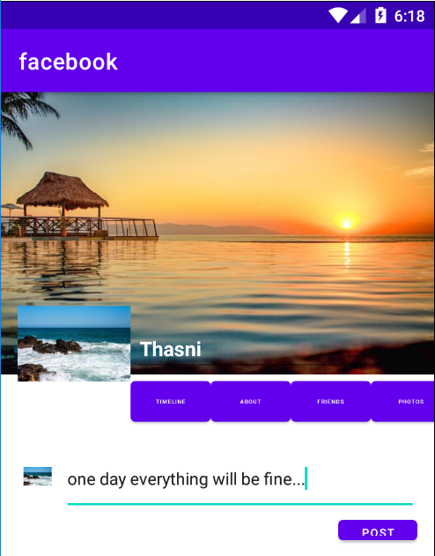

**Program No:08 Date:14-09-2022**

**Aim**:Develop an application that toggles image using FrameLayout.

**Program Code:**

**Activity_main.xml**

*<?*xml version="1.0" encoding="utf-8"*?>*<FrameLayout xmlns:android="http://schemas.android.com/apk/res/android"  
 android:id="@+id/frameLayout"  
 android:layout_width="fill_parent"  
 android:layout_height="fill_parent">  
 <ImageView  
 android:id="@+id/image1"  
 android:layout_width="match_parent"  
 android:layout_height="400dp"  
 android:scaleType="center"  
 android:src="@drawable/sea2"/>  
 <ImageView  
 android:id="@+id/image2"  
 android:layout_width="match_parent"  
 android:layout_height="400dp"  
 android:scaleType="centerCrop"  
 android:src="@drawable/sea3"/>  
  
</FrameLayout>

**MainActivity.java**

package com.example.toggle;  
  
import androidx.appcompat.app.AppCompatActivity;  
  
import android.os.Bundle;  
import android.view.View;  
import android.widget.ImageView;  
  
public class MainActivity extends AppCompatActivity {  
 ImageView i1,i2;  
  
 @Override  
 protected void onCreate(Bundle savedInstanceState) {  
 super.onCreate(savedInstanceState);  
 setContentView(R.layout.*activity_main*);  
 i1=findViewById(R.id.*image1*);  
 i2=findViewById(R.id.*image2*);  
 i2.setOnClickListener(new View.OnClickListener() {  
 @Override  
 public void onClick(View view) {  
 i2.setVisibility(view.*GONE*);  
 i1.setVisibility(view.*VISIBLE*);  
 }  
 });  
 i1.setOnClickListener(new View.OnClickListener() {  
 @Override  
 public void onClick(View view) {  
 i1.setVisibility(View.*GONE*);  
 i2.setVisibility(View.*VISIBLE*);  
 }  
 });  
 }  
}

**Result:** Program compiled successfully and output verified.

**Output**





**Program No: 09 Date:16-09-2022**

**Aim**:Web application to implement implicit intent.

**Program Code:**

**activity.xml**

*<?*xml version="1.0" encoding="utf-8"*?>*<LinearLayout xmlns:android="http://schemas.android.com/apk/res/android"  
 xmlns:app="http://schemas.android.com/apk/res-auto"  
 xmlns:tools="http://schemas.android.com/tools"  
 android:layout_width="match_parent"  
 android:layout_height="match_parent"  
 tools:context=".MainActivity">  
  
 <EditText  
 android:id="@+id/t1"  
 android:layout_width="wrap_content"  
 android:layout_height="wrap_content"  
 android:text="http://www.google.co.in"  
 android:textColor="@color/design_default_color_secondary"/>  
 <Button  
 android:id="@+id/btn1"  
 android:layout_width="wrap_content"  
 android:layout_height="wrap_content"  
 android:text="click"  
 android:textColor="@color/design_default_color_error"/>  
  
</LinearLayout>

**MainActivity.java**

package com.example.implicit_intent;  
  
import androidx.appcompat.app.AppCompatActivity;  
  
import android.content.Intent;  
import android.net.Uri;  
import android.os.Bundle;  
import android.view.View;  
import android.widget.Button;  
import android.widget.EditText;  
  
public class MainActivity extends AppCompatActivity {  
 EditText et1;  
 Button b1;  
  
 @Override  
 protected void onCreate(Bundle savedInstanceState) {  
 super.onCreate(savedInstanceState);  
 setContentView(R.layout.*activity_main*);  
 et1=findViewById(R.id.*t1*);  
 b1=findViewById(R.id.*btn1*);  
 b1.setOnClickListener(new View.OnClickListener() {  
 @Override  
 public void onClick(View view) {  
 String url=et1.getText().toString();  
 Intent i=new Intent(Intent.*ACTION_VIEW*, Uri.*parse*(url));  
 startActivity(i);  
 }  
 });  
 }  
}

**Result:** Program compiled successfully and output verified.

**Output**

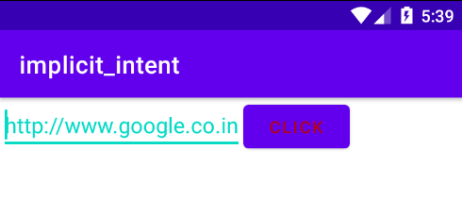

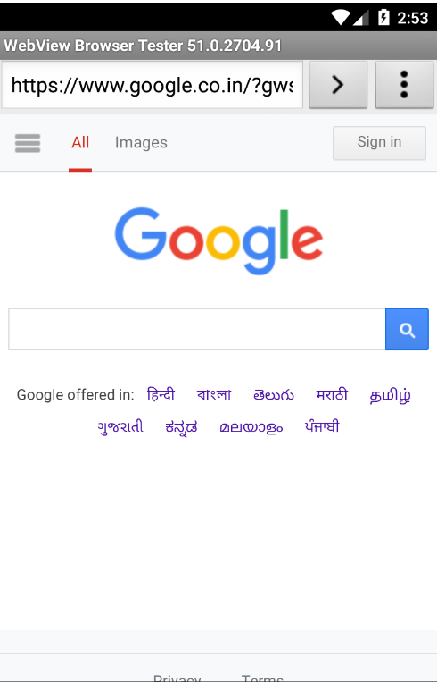

**Program No: 10 Date:20-09-2022**

**Aim**:Implement options menu to navigate two activities.

**Program Code:**

**Activity_main.xml**

*<?*xml version="1.0" encoding="utf-8"*?>*<androidx.constraintlayout.widget.ConstraintLayout xmlns:android="http://schemas.android.com/apk/res/android"  
 xmlns:app="http://schemas.android.com/apk/res-auto"  
 xmlns:tools="http://schemas.android.com/tools"  
 android:layout_width="match_parent"  
 android:layout_height="match_parent"  
 tools:context=".MainActivity">  
  
 <TextView  
 android:layout_width="wrap_content"  
 android:layout_height="wrap_content"  
 android:text="Hello World!"  
 app:layout_constraintBottom_toBottomOf="parent"  
 app:layout_constraintLeft_toLeftOf="parent"  
 app:layout_constraintRight_toRightOf="parent"  
 app:layout_constraintTop_toTopOf="parent" />

</androidx.constraintlayout.widget.ConstraintLayout>

**menu.xml**

*<?*xml version="1.0" encoding="utf-8"*?>*<menu xmlns:android="http://schemas.android.com/apk/res/android">  
 <item android:id="@+id/item1"  
 android:title="File"/>  
 <item android:id="@+id/item2"  
 android:title="Edit">  
 <menu>  
 <item android:id="@+id/sitem1"  
 android:title="Cut"/>  
 <item android:id="@+id/sitem2"  
 android:title="Copy"/>  
 <item android:id="@+id/sitem3"  
 android:title="Paste"/>  
 </menu>  
 </item>  
 <item android:id="@+id/item3"  
 android:title="View"/>

</menu>

**MainActivity.java**

package com.example.option_menu;  
  
import androidx.annotation.NonNull;  
import androidx.appcompat.app.AppCompatActivity;  
  
import android.os.Bundle;  
import android.view.Menu;  
import android.view.MenuItem;  
import android.widget.Toast;  
  
public class MainActivity extends AppCompatActivity {  
  
 @Override  
 protected void onCreate(Bundle savedInstanceState) {  
 super.onCreate(savedInstanceState);  
 setContentView(R.layout.*activity_main*);  
 }  
  
 @Override  
 public boolean onCreateOptionsMenu(Menu menu) {  
 getMenuInflater().inflate(R.menu.*menu*,menu);  
 return true;  
 }  
  
 @Override  
 public boolean onOptionsItemSelected(@NonNull MenuItem item) {  
 switch (item.getItemId()){  
 case R.id.*item1*:  
 Toast.*makeText*(getApplicationContext(),"File selected",Toast.*LENGTH_SHORT*).show();  
 break;  
 case R.id.*item2*:  
 Toast.*makeText*(getApplicationContext(),"Edit selected",Toast.*LENGTH_SHORT*).show();  
 break;  
 case R.id.*sitem1*:  
 Toast.*makeText*(getApplicationContext(),"Cut selected",Toast.*LENGTH_SHORT*).show();  
 break;  
 case R.id.*sitem2*:  
 Toast.*makeText*(getApplicationContext(),"Copy selected",Toast.*LENGTH_SHORT*).show();  
 break;  
 case R.id.*sitem3*:  
 Toast.*makeText*(getApplicationContext(),"Paste selected",Toast.*LENGTH_SHORT*).show();  
 break;  
 case R.id.*item3*:  
 Toast.*makeText*(getApplicationContext(),"View selected",Toast.*LENGTH_SHORT*).show();  
 break;  
  
 }  
 return super.onOptionsItemSelected(item);  
 }

}

**Result:** Program compiled successfully and output verified.

**Output**

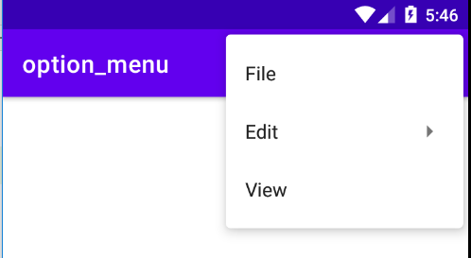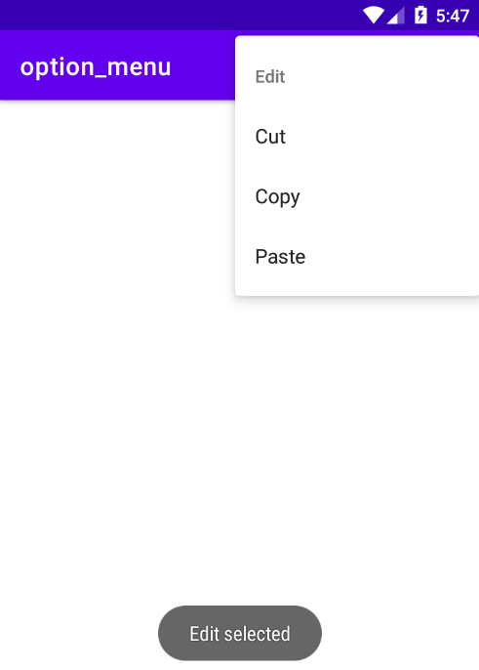

**Program No:11 Date:27-09-2022**

**Aim**: Develop an application that uses ArrayAdapter with ListView.

**Program Code:**

**Activity_main.xml**

*<?*xml version="1.0" encoding="utf-8"*?>*<LinearLayout xmlns:android="http://schemas.android.com/apk/res/android"  
 xmlns:app="http://schemas.android.com/apk/res-auto"  
 xmlns:tools="http://schemas.android.com/tools"  
 android:layout_width="match_parent"  
 android:layout_height="match_parent"  
 app:layout_behavior="@string/appbar_scrolling_view_behavior"  
 tools:context=".MainActivity"  
 tools:showIn="@layout/activity_main">  
  
 <ListView  
 android:layout_width="match_parent"  
 android:layout_height="match_parent"  
 android:id="@+id/l"/>

</LinearLayout>

**MainActivity.java**

package com.example.array_adapter;  
  
import androidx.appcompat.app.AppCompatActivity;  
  
import android.content.Intent;  
import android.os.Bundle;  
import android.view.View;  
import android.widget.AdapterView;  
import android.widget.ArrayAdapter;  
import android.widget.ListView;  
  
public class MainActivity extends AppCompatActivity {  
 ListView l;  
 String[] p={"A.P.J Abdul Kalam","Sachin Tendulkar"," Cristiano Ronaldo"};  
  
 @Override  
 protected void onCreate(Bundle savedInstanceState) {  
 super.onCreate(savedInstanceState);  
 setContentView(R.layout.*activity_main*);  
 l=findViewById(R.id.*l*);  
 ArrayAdapter <String>adapter=new ArrayAdapter<String>(this, android.R.layout.*simple_list_item_1*,p);  
 l.setAdapter(adapter);  
 l.setOnItemClickListener(new AdapterView.OnItemClickListener() {  
 @Override  
 public void onItemClick(AdapterView<?> adapterView, View view, int i, long l) {  
 if(i==0)  
 {  
 Intent s=new Intent(MainActivity.this,MainActivity2.class);  
 startActivity(s);  
 }  
 else if (i==1)  
 {  
 Intent s=new Intent(MainActivity.this,MainActivity3.class);  
 startActivity(s);  
 }  
 else if (i==2)  
 {  
 Intent s=new Intent(MainActivity.this,MainActivity4.class);  
 startActivity(s);  
  
 }  
  
 }  
 });  
 }

}

**Activity_main2.xml**

*<?*xml version="1.0" encoding="utf-8"*?>*<androidx.constraintlayout.widget.ConstraintLayout xmlns:android="http://schemas.android.com/apk/res/android"  
 xmlns:app="http://schemas.android.com/apk/res-auto"  
 xmlns:tools="http://schemas.android.com/tools"  
 android:layout_width="match_parent"  
 android:layout_height="match_parent"  
 tools:context=".MainActivity2">  
<TextView  
 android:layout_width="match_parent"  
 android:layout_height="match_parent"  
 android:text="Born on 15th October 1931 at Rameswaram in Tamil Nadu, Dr.Avul Pakir Jainulabdeen Abdul Kalam specialized in Aeronautical Engineering from Madras Institute of Technology."/>  
</androidx.constraintlayout.widget.ConstraintLayout>

**MainActivity2.java**

package com.example.array_adapter;  
  
import androidx.appcompat.app.AppCompatActivity;  
  
import android.os.Bundle;  
  
public class MainActivity extends AppCompatActivity {  
  
 @Override  
 protected void onCreate(Bundle savedInstanceState) {  
 super.onCreate(savedInstanceState);  
 setContentView(R.layout.*activity_main*);  
 }  
}

**Activity_main3.xml**

*<?*xml version="1.0" encoding="utf-8"*?>*<androidx.constraintlayout.widget.ConstraintLayout xmlns:android="http://schemas.android.com/apk/res/android"  
 xmlns:app="http://schemas.android.com/apk/res-auto"  
 xmlns:tools="http://schemas.android.com/tools"  
 android:layout_width="match_parent"  
 android:layout_height="match_parent"  
 tools:context=".MainActivity3">  
<TextView  
 android:layout_width="match_parent"  
 android:layout_height="match_parent"  
 android:text="Sachin Tendulkar was the most complete batter of his time, the most prolific run-maker of all time, and arguably the biggest cricket icon the game has ever known."/>  
</androidx.constraintlayout.widget.ConstraintLayout>

**MainActivity3.java**

package com.example.array_adapter;  
  
import androidx.appcompat.app.AppCompatActivity;  
  
import android.os.Bundle;  
  
public class MainActivity extends AppCompatActivity {  
  
 @Override  
 protected void onCreate(Bundle savedInstanceState) {  
 super.onCreate(savedInstanceState);  
 setContentView(R.layout.*activity_main*);  
 }  
}

**Activity_main4.xml**

*<?*xml version="1.0" encoding="utf-8"*?>*<androidx.constraintlayout.widget.ConstraintLayout xmlns:android="http://schemas.android.com/apk/res/android"  
 xmlns:app="http://schemas.android.com/apk/res-auto"  
 xmlns:tools="http://schemas.android.com/tools"  
 android:layout_width="match_parent"  
 android:layout_height="match_parent"  
 tools:context=".MainActivity4">  
<TextView  
 android:layout_width="match_parent"  
 android:layout_height="match_parent"  
 android:text="In February 2021, Ronaldo became the first person in the world to reach 500 million followers across Facebook, Instagram and Twitter."/>  
</androidx.constraintlayout.widget.ConstraintLayout>

**MainActivity4.java**

package com.example.array_adapter;  
  
import androidx.appcompat.app.AppCompatActivity;  
  
import android.os.Bundle;  
  
public class MainActivity extends AppCompatActivity {  
  
 @Override  
 protected void onCreate(Bundle savedInstanceState) {  
 super.onCreate(savedInstanceState);  
 setContentView(R.layout.*activity_main*);  
 }  
}

**Result:** Program compiled successfully and output verified.

**Output**

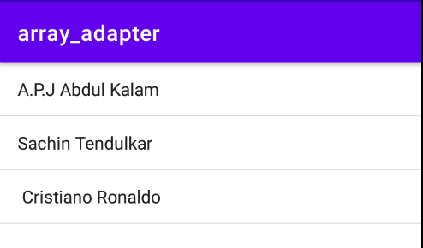

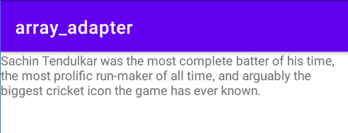

**Program No:12 Date:12-10-2022**

**Aim**: Perform exception handling.

**Program Code:**

**Activity_main.xml**

*<?*xml version="1.0" encoding="utf-8"*?>*<RelativeLayout xmlns:android="http://schemas.android.com/apk/res/android"  
 xmlns:app="http://schemas.android.com/apk/res-auto"  
 xmlns:tools="http://schemas.android.com/tools"  
 android:layout_width="match_parent"  
 android:layout_height="match_parent"  
 tools:context=".MainActivity">  
  
 <TextView  
 android:layout_width="wrap_content"  
 android:layout_height="wrap_content"  
 android:id="@+id/tv1" />  
  
</RelativeLayout>

**MainActivity.java**

package com.example.exceptionhandling;  
  
import androidx.appcompat.app.AppCompatActivity;  
  
import android.os.Bundle;  
import android.widget.TextView;  
import android.widget.Toast;  
  
public class MainActivity extends AppCompatActivity {  
 TextView tv1;  
  
 @Override  
 protected void onCreate(Bundle savedInstanceState) {  
 super.onCreate(savedInstanceState);  
 setContentView(R.layout.*activity_main*);  
 try {  
 tv1.setText("WELCOME");  
 }  
 catch (Exception e)  
 {  
 Toast.*makeText*(this,e.getMessage(),Toast.*LENGTH_LONG*).show();  
 }  
 }

}

**Result:** Program compiled successfully and output verified.

**Output**

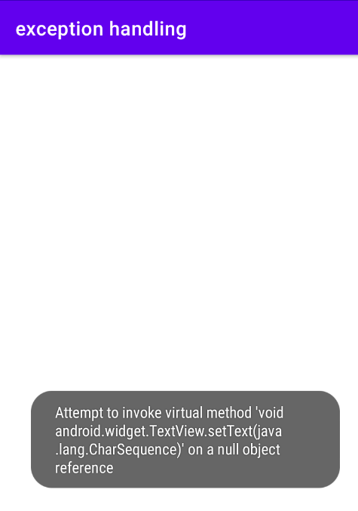

**Program No:13 Date:25-10-2022**

**Aim**: Develop an application that use GridView with images and display Alertbox on selection.

**Program Code:**

**Activity_main.xml**

*<?*xml version="1.0" encoding="utf-8"*?>*<GridLayout xmlns:android="http://schemas.android.com/apk/res/android"  
 xmlns:app="http://schemas.android.com/apk/res-auto"  
 xmlns:tools="http://schemas.android.com/tools"  
 android:layout_width="match_parent"  
 android:layout_height="match_parent"  
 tools:context=".MainActivity">  
  
 <ImageView  
 android:layout_width="400dp"  
 android:layout_height="200dp"  
 android:id="@+id/messi"  
 android:src="@drawable/messi"  
 android:scaleType="centerCrop"  
 android:layout_row="0"  
 android:layout_column="0" />  
 <ImageView  
 android:layout_width="wrap_content"  
 android:layout_height="400dp"  
 android:layout_column="0"  
 android:scaleType="centerCrop"  
 android:src="@drawable/ronaldo"  
 android:id="@+id/ronaldo"  
 android:layout_row="1"/>  
  
</GridLayout>

**MainActivity.java**

package com.example.gridviewimage;  
  
import androidx.appcompat.app.AppCompatActivity;  
  
import android.os.Bundle;  
import android.view.View;  
import android.widget.ImageView;  
import android.widget.Toast;  
  
public class MainActivity extends AppCompatActivity {  
 ImageView messi,ronaldo;  
  
 @Override  
 protected void onCreate(Bundle savedInstanceState) {  
 super.onCreate(savedInstanceState);  
 setContentView(R.layout.*activity_main*);  
 messi=findViewById(R.id.*messi*);  
 ronaldo=findViewById(R.id.*ronaldo*);  
 messi.setOnClickListener(new View.OnClickListener() {  
 @Override  
 public void onClick(View view) {  
 Toast.*makeText*(getApplicationContext(),"Messi",Toast.*LENGTH_LONG*).show();  
 }  
 });  
 ronaldo.setOnClickListener(new View.OnClickListener() {  
 @Override  
 public void onClick(View view) {  
 Toast.*makeText*(getApplicationContext(),"Ronaldo",Toast.*LENGTH_LONG*).show();  
 }  
 });  
 }  
}

**Result:** Program compiled successfully and output verified.

**Output**

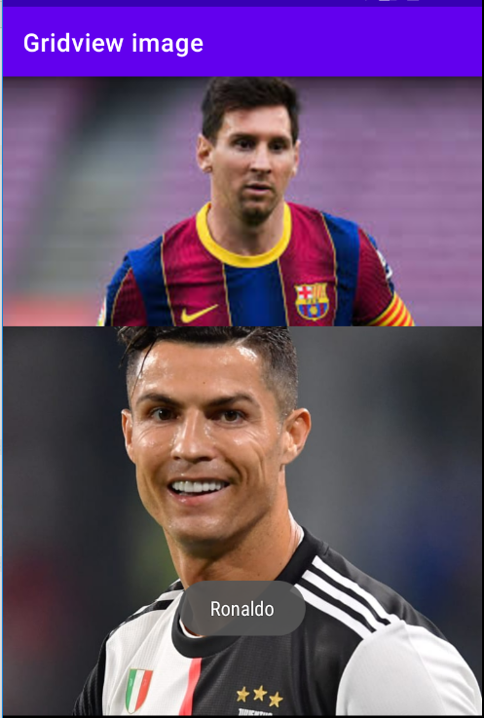

**Program No:14 Date:28-10-2022**

**Aim**: Develop an application that implements Spinner component and perform event handling.

**Program Code:**

**Activity_main.xml**

*<?*xml version="1.0" encoding="utf-8"*?>*<androidx.constraintlayout.widget.ConstraintLayout xmlns:android="http://schemas.android.com/apk/res/android"  
 xmlns:app="http://schemas.android.com/apk/res-auto"  
 xmlns:tools="http://schemas.android.com/tools"  
 android:layout_width="match_parent"  
 android:layout_height="match_parent"  
 tools:context=".MainActivity">  
  
 <TextView  
 android:layout_width="wrap_content"  
 android:layout_height="wrap_content"  
 android:textSize="20dp"  
 android:text="Select your nation"/>  
 <Spinner  
 android:id="@+id/spinner"  
 android:layout_width="149dp"  
 android:layout_height="40dp"  
 android:layout_marginBottom="8dp"  
 android:layout_marginStart="8dp"  
 android:layout_marginEnd="8dp"  
 android:layout_marginTop="8dp"  
 app:layout_constraintBottom_toBottomOf="parent"  
 app:layout_constraintEnd_toEndOf="parent"  
 app:layout_constraintHorizontal_bias="0.502"  
 app:layout_constraintStart_toStartOf="parent"  
 app:layout_constraintTop_toTopOf="parent"  
 app:layout_constraintVertical_bias="0.498"  
 />  
  
</androidx.constraintlayout.widget.ConstraintLayout>

**MainActivity.java**

package com.example.spinner;  
  
import androidx.appcompat.app.AppCompatActivity;  
  
import android.os.Bundle;  
import android.view.View;  
import android.widget.AdapterView;  
import android.widget.ArrayAdapter;  
import android.widget.Spinner;  
import android.widget.Toast;  
  
public class MainActivity extends AppCompatActivity implements AdapterView.OnItemSelectedListener {  
 String[] country={"India","USA","America","Canada","Others"};  
  
 @Override  
 protected void onCreate(Bundle savedInstanceState) {  
 super.onCreate(savedInstanceState);  
 setContentView(R.layout.*activity_main*);  
 Spinner spin=(Spinner)findViewById(R.id.*spinner*);  
 spin.setOnItemSelectedListener(this);  
 ArrayAdapter aa= new ArrayAdapter(this, android.R.layout.*simple_spinner_item*,country);  
 aa.setDropDownViewResource(android.R.layout.*simple_spinner_dropdown_item*);  
 spin.setAdapter(aa);  
 }  
  
 @Override  
 public void onItemSelected(AdapterView<?> arg0, View arg1, int position, long id)  
 {  
 Toast.*makeText*(getApplicationContext(),country[position],Toast.*LENGTH_LONG*).show();  
 }  
 public void onNothingSelected(AdapterView<?> adapterView){  
 }  
}

**Result:** Program compiled successfully and output verified.

**Output**

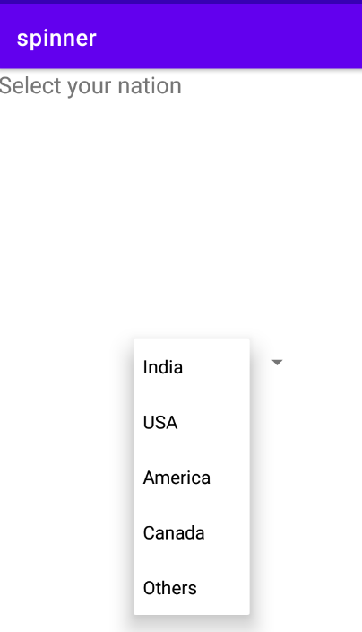 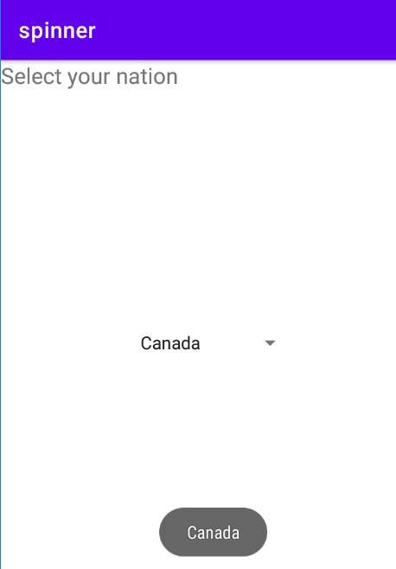

**Program No:15 Date:04-11-2022**

**Aim**: Implement Navigation drawer.

**Program Code:**

**Activity_main.xml**

*<?*xml version="1.0" encoding="utf-8"*?>*<androidx.drawerlayout.widget.DrawerLayout  
 xmlns:android="http://schemas.android.com/apk/res/android"  
 xmlns:app="http://schemas.android.com/apk/res-auto"  
 xmlns:tools="http://schemas.android.com/tools"  
 android:id="@+id/my_drawer_layout"  
 android:layout_width="match_parent"  
 android:layout_height="match_parent"  
 tools:context=".MainActivity"  
 tools:ignore="HardcodedText">  
  
 <LinearLayout  
 android:layout_width="match_parent"  
 android:layout_height="match_parent">  
  
 <TextView  
 android:layout_width="match_parent"  
 android:layout_height="wrap_content"  
 android:layout_marginTop="128dp"  
 android:gravity="center"  
 android:textSize="18sp" />  
 </LinearLayout>  
  
 <com.google.android.material.navigation.NavigationView  
 android:layout_width="wrap_content"  
 android:layout_height="match_parent"  
 android:layout_gravity="start"  
 app:menu="@menu/navigation_menu" />  
  
</androidx.drawerlayout.widget.DrawerLayout>

**Navigation_menu.xml**

*<?*xml version="1.0" encoding="utf-8"*?>*<menu xmlns:android="http://schemas.android.com/apk/res/android">  
 xmlns:tools="http://schemas.android.com/tools"  
 tools:ignore="HardcodedText">  
 <item  
 android:id="@+id/nav_account"  
 android:title="My account"/>  
 <item  
 android:id="@+id/nav_settings"  
 android:title="Settings"/>  
 <item  
 android:id="@+id/nav_logout"  
 android:title="Logout"/>  
  
</menu>

**Strings.xml**

<resources>  
 <string name="app_name">Navigationdrawer</string>  
 <string name="nav_open">Open</string>  
 <string name="nav_close">Close</string>  
</resources>

**MainActivity.java**

package com.example.navigationdrawer;  
import androidx.annotation.NonNull;  
import androidx.appcompat.app.ActionBarDrawerToggle;  
import androidx.appcompat.app.AppCompatActivity;  
import androidx.drawerlayout.widget.DrawerLayout;  
import android.os.Bundle;  
import android.view.MenuItem;  
  
public class MainActivity extends AppCompatActivity {  
 public DrawerLayout drawerLayout;  
 public ActionBarDrawerToggle actionBarDrawerToggle;  
  
 @Override  
 protected void onCreate(Bundle savedInstanceState) {  
 super.onCreate(savedInstanceState);  
 setContentView(R.layout.*activity_main*);  
 drawerLayout=findViewById(R.id.*my_drawer_layout*);  
 actionBarDrawerToggle=new ActionBarDrawerToggle(this,drawerLayout,R.string.*nav_open*,R.string.*nav_close*);  
 drawerLayout.addDrawerListener(actionBarDrawerToggle);  
 actionBarDrawerToggle.syncState();  
 getSupportActionBar().setDisplayHomeAsUpEnabled(true);  
  
 }  
 public boolean onOptionsItemSelected(@NonNull MenuItem item){  
 if (actionBarDrawerToggle.onOptionsItemSelected(item)){  
 return true;  
 }  
 return super.onOptionsItemSelected(item);  
 }  
}

**Result:** Program compiled successfully and output verified.

**Output**

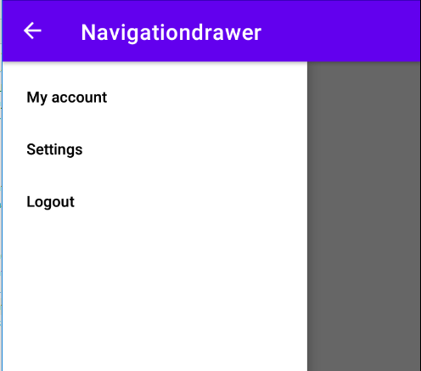

**Program No:16 Date:11-11-2022**

**Aim**: Create a database using SQLite and perform operations.

**Program Code:**

**Activity_main.xml**

*<?*xml version="1.0" encoding="utf-8"*?>*<RelativeLayout xmlns:android="http://schemas.android.com/apk/res/android"  
 xmlns:app="http://schemas.android.com/apk/res-auto"  
 xmlns:tools="http://schemas.android.com/tools"  
 android:layout_width="match_parent"  
 android:layout_height="match_parent"  
 tools:context=".MainActivity"  
 android:orientation="horizontal">  
 <TextView  
 android:layout_width="match_parent"  
 android:layout_height="wrap_content"  
 android:text="Please enter the details below"  
 android:textSize="24dp"  
 android:id="@+id/texttitle"/>  
 <EditText  
 android:layout_width="match_parent"  
 android:layout_height="wrap_content"  
 android:hint="Name"  
 android:textSize="24dp"  
 android:inputType="textPersonName"  
 android:id="@+id/et1"  
 android:layout_below="@+id/texttitle"/>  
 <EditText  
 android:layout_width="wrap_content"  
 android:layout_height="wrap_content"  
 android:hint="contact"  
 android:textSize="24dp"  
 android:inputType="number"  
 android:id="@+id/et2"  
 android:layout_below="@+id/et1"/>  
 <EditText  
 android:layout_width="wrap_content"  
 android:layout_height="wrap_content"  
 android:hint="DOB"  
 android:textSize="24dp"  
 android:inputType="number"  
 android:id="@+id/et3"  
 android:layout_below="@+id/et2"/>  
 <Button  
 android:layout_width="wrap_content"  
 android:layout_height="wrap_content"  
 android:text="Insert"  
 android:textSize="24dp"  
 android:id="@+id/Insert"  
 android:layout_below="@id/et3"/>  
 <Button  
 android:layout_width="wrap_content"  
 android:layout_height="wrap_content"  
 android:text="Update"  
 android:textSize="24dp"  
 android:id="@+id/Update"  
 android:layout_below="@+id/Insert"/>  
 <Button  
 android:layout_width="wrap_content"  
 android:layout_height="wrap_content"  
 android:text="Delete"  
 android:textSize="24dp"  
 android:id="@+id/Delete"  
 android:layout_below="@+id/Update"/>  
 <Button  
 android:layout_width="wrap_content"  
 android:layout_height="wrap_content"  
 android:text="View"  
 android:id="@+id/View"  
 android:textSize="24dp"  
 android:layout_below="@+id/Delete"/>  
</RelativeLayout>

**DBHelper.java**

package com.example.pgm12;  
import android.content.ContentValues;  
import android.content.Context;  
import android.database.Cursor;  
import android.database.sqlite.SQLiteDatabase;  
import android.database.sqlite.SQLiteOpenHelper;  
  
import androidx.annotation.Nullable;  
  
  
public class DBHelper extends SQLiteOpenHelper {  
 public DBHelper(@Nullable Context context){  
 super(context,"userdata.db",null,1);  
  
 }  
 public void onCreate(SQLiteDatabase DB){  
 DB.execSQL("create Table userdetails(name TEXT primary key,contact TEXT,dob TEXT)");  
  
 }  
 public void onUpgrade(SQLiteDatabase DB,int i,int i1) {  
 DB.execSQL("drop table if exists userdetails");  
 }  
 public Boolean insertData(String name,String contact,String dob)  
 {  
 SQLiteDatabase DB=this.getWritableDatabase();  
 ContentValues contentValues=new ContentValues();  
 contentValues.put("name",name);  
 contentValues.put("contact",contact);  
 contentValues.put("dob",dob);  
 long result=DB.insert("Userdetails",null,contentValues);  
 if(result==-1)  
 return false;  
 else  
 return true;  
 }  
  
 public Boolean updateData(String name,String contact,String dob)  
 {  
 SQLiteDatabase DB=this.getWritableDatabase();  
 ContentValues contentValues=new ContentValues();  
 contentValues.put("name",name);  
 contentValues.put("contact",contact);  
 contentValues.put("dob",dob);  
 Cursor cursor=DB.rawQuery("select * from userdetails where name=?",new String[]{name});  
 if (cursor.getCount()>0) {  
 long result = DB.update("userdetails", contentValues, "name=?", new String[]{name});  
 if (result == -1)  
 return false;  
 else  
 return true;  
 }  
 else  
 {  
 return false;  
 }  
  
 }  
 public boolean deleteData(String name){  
 SQLiteDatabase DB=this.getWritableDatabase();  
 Cursor cursor=DB.rawQuery("select * from userdetails where name=?",new String[]{name});  
 if (cursor.getCount()>0){  
 long result=DB.delete("userdetails","name=?",new String[]{name});  
 if (result==-1)  
 return false;  
 else  
 return true;  
 }  
 else  
 {  
 return false;  
 }  
 }  
 public Cursor getData(){  
 SQLiteDatabase DB=this.getWritableDatabase();  
 Cursor cursor=DB.rawQuery("select * from userdetails",null);  
 return cursor;  
 }  
  
}

**MainAvtivity.java**

package com.example.pgm12;  
import androidx.appcompat.app.AlertDialog;  
import androidx.appcompat.app.AppCompatActivity;  
  
import android.os.Bundle;  
import android.view.View;  
import android.widget.Button;  
import android.widget.EditText;  
import android.widget.Toast;  
import android.database.Cursor;  
  
public class MainActivity extends AppCompatActivity {  
 EditText et1,et2,et3;  
 Button Insert,Update,Delete,View;  
 DBHelper db;  
  
  
 @Override  
 protected void onCreate(Bundle savedInstanceState) {  
 super.onCreate(savedInstanceState);  
 setContentView(R.layout.*activity_main*);  
 et1=findViewById(R.id.*et1*);  
 et2=findViewById(R.id.*et2*);  
 et3=findViewById(R.id.*et3*);  
 Insert=findViewById(R.id.*Insert*);  
 Update=findViewById(R.id.*Update*);  
 Delete=findViewById(R.id.*Delete*);  
 View=findViewById(R.id.*View*);  
 db=new DBHelper(this);  
 Insert.setOnClickListener(new View.OnClickListener() {  
 @Override  
 public void onClick(android.view.View view) {  
 String name=et1.getText().toString();  
 String contact=et2.getText().toString();  
 String dob=et3.getText().toString();  
 boolean checkInsertData=db.insertData(name,contact,dob);  
 if(checkInsertData==true)  
 Toast.*makeText*(MainActivity.this,"New entry inserted",Toast.*LENGTH_LONG*).show();  
 else  
 Toast.*makeText*(MainActivity.this,"New entry is not inserted",Toast.*LENGTH_LONG*).show();  
  
  
  
 }  
 });  
 Update.setOnClickListener(new View.OnClickListener() {  
 public void onClick(android.view.View view) {  
 String name= et1.getText().toString();  
 String contact=et2.getText().toString();  
 String dob= et3.getText().toString();  
 boolean checkUpdateData= db.updateData(name,contact,dob);  
 if(checkUpdateData==true)  
 Toast.*makeText*(MainActivity.this,"Entry updated",Toast.*LENGTH_LONG*).show();  
 else  
 Toast.*makeText*(MainActivity.this,"Entry Not Updated",Toast.*LENGTH_LONG*).show();  
 }  
 });  
 Delete.setOnClickListener(new View.OnClickListener() {  
 @Override  
 public void onClick(android.view.View view) {  
 String name= et1.getText().toString();  
  
 boolean checkDeleteData= db.deleteData(name);  
 if(checkDeleteData==true)  
 Toast.*makeText*(MainActivity.this,"Entry deleted",Toast.*LENGTH_LONG*).show();  
 else  
 Toast.*makeText*(MainActivity.this,"Entry Not deleted",Toast.*LENGTH_LONG*).show();  
 }  
 });  
 View.setOnClickListener(new View.OnClickListener() {  
 @Override  
 public void onClick(android.view.View view) {  
 Cursor res = db.getData();  
 if (res.getCount() == 0) {  
 Toast.*makeText*(MainActivity.this, "No entry exists", Toast.*LENGTH_LONG*).show();  
 return;  
 }  
 StringBuffer buffer = new StringBuffer();  
  
 while (res.moveToNext()) {  
 buffer.append("name:" + res.getString(0) + "\n");  
 buffer.append("contact:" + res.getString(1) + "\n");  
 buffer.append("date of birth:" + res.getString(2) + "\n\n\n\n\n");  
 }  
 AlertDialog.Builder builder = new AlertDialog.Builder(MainActivity.this);  
 builder.setCancelable(true);  
 builder.setTitle("User Enteries");  
 builder.setMessage(buffer.toString());  
 builder.show();  
 }  
 });  
 }  
}

**Result:** Program compiled successfully and output verified.

**Output**

